**PROJECT PHASE-I REPORT**

**FOOD DELIVERY SYSTEM USING B2B2C MODEL**



|  |  |
| --- | --- |
| **Guided by** | **Submitted by** |
| Mr. K.P. Singh | Chandra Prakash Singh Sengar |
|  | Jitendra Singh Soujanya |
|  | Lalit Chouhan |
|  | Somil Jain |
|  | Vivek Brahmane |

**Computer Engineering Department**

**Shri G.S. Institute of Technology and Science**

**Indore (M.P.)**

**2017-2018**

**DECLARATION**

We hereby declare that the project report entitled “Food delivery using B2B2C Model” submitted by us, Mr. Chandra Prakash Singh Sengar, Mr. Jitendra Singh Soujanya, Mr. Lalit Chouhan, Mr. Somil Jain, Mr. Vivek Brahmane to S.G.S.I.T.S. Indore in fulfilment of the requirement for the award of the degree of B.E. in COMPUTER ENGINEERING DEPARTMENT is a record of bonafide project work carried out by us under the guidance of Mr. K.P. Singh. We further declare that the work reported in this project has not been submitted and will not be submitted, either in part or in full, for the award of any other degree in this institute or any other institute or university.

DATE:

Chandra Prakash Singh Sengar Somil Jain

Jitendra Singh Soujanya Vivek Brahmane

Lalit Chouhan

**Shri G. S. Institute of Technology and Science Indore (M.P.)**



**RECOMMENDATION**

This is to certify that the report entitled “**Food Delivery System using B2B2C Model**” submitted by Chandra Prakash Singh Sengar, Jitendra Singh Soujanya, Lalit Chouhan, Somil Jain, Vivek Brahmane students of final year B.E. (Computer Engineering) in the year 2017-18 of the Institute, is a satisfactory account of their Project Phase-1 work based on syllabus and the same is recommended for the Phase-I examination.

Mr. K.P. Singh Dr.Urjita Thakar

**Guide** **Head**

Computer Engg Department Computer Engg Department

S.G.S.I.T.S. S.G.S.I.T.S.

Indore Indore

Dean Academic

S.G.S.I.T.S.

Indore

**Shri G. S. Institute of Technology and Science Indore (M.P.)**



**CERTIFICATE**

This is to certify that thereport entitled “**Food Delivery System using B2B2C Model**” submitted by Chandra Prakash Singh Sengar, Jitendra Singh Soujanya, Lalit Chouhan, Somil Jain, Vivek Brahmane students of final year B.E. (Computer Engineering) in the year 2017-2018 of this Institute is a satisfactory account of their Project Phase-I work based on syllabus.

**Internal Examiner External Examiner**

**ACKNOWLEDGEMENT**

We express our profound sense of gratitude to Mr. K.P. Singh, our project guide and mentor, who supported us to do project work. His continuous support and motivation helped us to bring forth our best. Having such guidance and expert advice in this field has been an amazing experience and one of the main reasons for the success of this project.

We are grateful to him, being Senior Programmer of the Department of Computer Engineering, thus providing necessary facilities to carry out our project work.

We would like to give our warm expressions of thanks to Dr. R. K. Saxena (Director), Dr. Urjita Thakar(HOD), Prof. D. A. Mehta (Dean Academics), Prof. B. M. Sharma (Dean Student Welfare) for providing all the facilities and academic environment during the course of study.

We would like to show our gratitude towards our Parents for their support, motivation and blessings. We sincerely wish to express, our gratefulness to all the members of the staff of computer engineering department who had extended their cooperation at all the times and have contributed in their own way in developing the project.

The successful completion of the project is not an individual effort. It is an outcome of the cumulative effort of number of people, each having their own importance to the objective.

We express love and respect towards our parents and all family members who are our strength in every work we do.

With a blend of gratitude, pleasure and great satisfaction we convey our indebtedness to all those who have directly or indirectly contributed to the successful completion of the project work.

Chandra Prakash Singh Sengar

Jitendra Singh Soujanya

Lalit Chouhan

Somil Jain

Vivek Brahmane

**Chapter : 1**

**Introduction**

Food Delivery System using B2B2C Model aims to provide a hassle free platform for selling different kinds of food items provided by different food hubs. Since there are many good food hubs in almost every city or town providing there services among a lot of people, many of them are doing really well and expanding their business at exponential rate since they have fund for doing so, but those who lacks infrastructural, financial, economical facilities are lying much behind in the race. These dominated group of shops need a reliable, robust, efficient, technically sound platform which will enable them to cope up in the market shared by economically sound vendors.

In the present scenario the people are very busy in their day-to-day life, that they even don’t have time to cook food for them. As we know that India is very involved in software industry and majority of people live away from home and food is something for which they have to compromise and they are very involved in their hectic schedule that to have proper food in the proper time is not in their fortune. Resulting they go for online food services which are performing really good in the food service market because of financial support but they are not in touch with those food hubs which provide good, delicious, hygienic, fresh and less priced food.

So this brings the need of a platform through which they can get freshly cooked food at their door step and help to grow the business of small food hubs providing better services at lesser cost. This software will also provide an opportunity to the food-hub owners to make available their food items to a large number of food connoisseur.

**1.1. Need of Project:**

* To provide Small food hubs a reliable, efficient, durable medium to spread their business door to door.
* To provide the platform to sell food items with very ease and among many places.
* To spread business of small food hubs and hence increasing their profit without any extra investment.
* This will help customers to reach the larger market.
* To enable the customers to access the Food-hub’s wide range of food items at their door step.
* Time is saved as the customer don’t need to visit food-hub.

**1.2. Problem Statement:**

Online food industry is available but it is dominated by the vendors having huge investment from the sponsors, but the small food hubs are lagging behind in the competition despite of selling their food at lower cost and of good quality but because of unavailability of proper infrastructure. Food-hubs are not making efficient use of technology to cover most of the market and this software will facilitate them to achieve this. Synchronized flow of data, services and how it should be implemented efficiently is the main issue.

**1.3. Objectives:**

* To increase the market reach of small food-hubs owned by shop-owners having less financial, economical, infrastructural and technical support.
* For increasing the sales of the small food-hubs by providing all their services door to door without much of a technical complexity and without any other financial investment.
* To provide ease to the customer by saving it’s time without compromising with its need.
* To provide best services by serving food that is delicious, healthy, freshly cooked and less priced in your vicinity in no time.
* Providing services to the customers at lower price as much as possible.
* To provide a proper and efficient communication among the different Business classes and between Business and Customer.

**1.4. Solution approach:**

Integrating all the resources into a single unit for solving the issues stated above in the problem statement using Business to Business to Customer Model (B2B2C). The communication between the shop-owners (Business-B) and the customers will be enabled by the admin (Business-A) who heads the system . And also the delivery will be processed by delivery boy who will facilitate the food product to be reached to the customer.

This software will provide a user-friendly and hassle-free environment for the Shop-owners and customers so the customers sitting at home can also easily use it. First of all the Customer/ Shop-owner needs to register on the app. Shop-owners can use their account to provide the menu of food items they serve. Shop-owners (small food hubs) will be provided with a wide range of functionalities like adding food items specifically provided by their shop in the menu, removing any particular food item if the food-hub is not able to deliver the food, Checking the order log and act accordingly.

The Customers can place an order out of the variety given by various shop-owners. Various functionalities available to customer are placing an order for a food item or a bunch of food item from a particular hub, viewing the menu served by a particular food hub, having a look on all the orders that customer had placed.

This will be achieved by analysing all the necessary aspects of the above problem case and by keeping the points in the mind, we’ll develop a software using Android which will facilitate easy management of the system helping the owners of small hubs and the customers at it best possible way. Android makes us available all the features of Object Oriented Software Development tool kit for making a solution of real life problem.

**1.5. Organization of Project Report:**

The report is organized in the following chapters:

Chapter 1 Describe the basic needs and objectives of the project and it also describes scope and limitations of the project.

Chapter 2 Deals with background study and technical details.

Chapter 3 Deals with the feasibility study, functional and non-functional requirements, hardware and software specifications.

Chapter 4 Focuses on the Design details. Architecture of the system is developed.

Chapter 5 Is the conclusion where a summary of the project is presented.

**Chapter : 2**

**Literature Survey**

For making Food delivery this system will be using the B2B2C model solution approach to deal with the issues .

**2.1. Business to Business to Customer**

Business to Business to Consumer (B2B2C) is an emerging Ecommerce business model that finely integrates Business to Business (B2B) and Business to consumer (B2C). In short, it is an effective business model that makes everything easy in a business cycle from a Manufacturer to the End user.

**2.1.1. What is B2B?**

B2B-[Business to Business](http://www.bizbilla.com/)model is selling or exchange  of business products or services between various businesses. You can make a business transaction in your own city, state and country to other parts of the world through [b2b](http://www.bizbilla.com/)business. B2B is a business stream which connects Manufacturers, suppliers, buyers, sellers, wholesalers, dealers, distributors, importers, exporters online through various b2b websites or web portals.

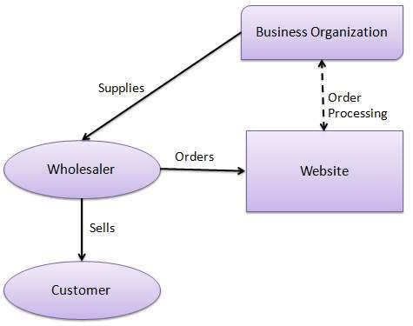

**2.1.2. What Is B2C?**

B2C-[Business to Customer](http://www.ecbilla.com/)model is the commerce transaction of Business products or services from a business to a customer directly through Internet.

 

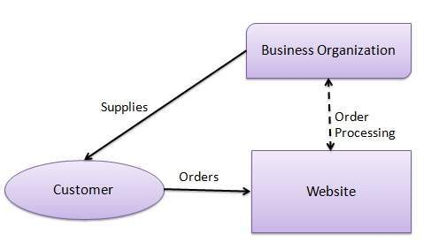

**How B2B and B2C integrates to form a B2B2C model?**  
   
A B2B2C Model is a fine integration of the B2B & B2C business models that serves a direct business transaction from a Manufacturer to End user. It is an emerging [Ecommerce](http://www.ecbilla.com/)model which is exclusively known for its easier product and service transaction in a business. The main motto of the B2B2C model is to emulate the counterparts of B2B and B2C model and bring a best and easy business system to the public.  
   
So, When a manufacturer or a customer can contact them directly there would be a good business relationship between them and the business transaction will go good, better and the best.

B2B2C can help a company market its product or service more effectively by entering a B2B relationship with a company whose expertise is selling online - a B2C (Business2Consumer or Business-to-Consumer) company. In return, the B2C company is able to offer its customers more options. Often, a third entity serves as a middleman to move goods between the provider and the e-commerce vendor or to aggregate customers the other two parties want to reach.

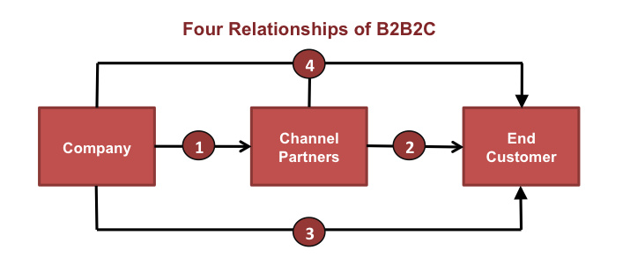

Whether an organization is marketing a technology platform, a food vendors or a healthcare service, this approach to keeping the individual top of mind (whether that person is an executive or healthcare consumer) will ultimately drive more impactful and effective marketing efforts.

**Background**

**2.2. ANDROID OS**

Android is a mobile operating system (OS) based on the Linux kernel and currently developed by Google . Android is designed primarily for touch screen mobile devices such as Smart phones and tablet computers, with specialized user interfaces for televisions (Android TV), cars (Android Auto), and wrist watches (Android Wear). Despite being primarily designed for touch screen input, it has also been used in game consoles, digital cameras, regular PCs, and other electronics. Android's default user interface is based on direct manipulation, using touch inputs, that loosely correspond to real-world actions, like swiping, tapping, pinching, and reverse pinching to manipulate on-screen objects, and a virtual keyboard. The response to user input is designed to be immediate and provides a fluid touch interface, often using the vibration capabilities of the device to provide hap tic feedback to the user. Internal hardware such as accelerometer, gyroscopes and proximity sensors are used by some applications to respond to additional user actions, for example adjusting the screen from portrait to landscape depending on how the device is oriented, or allowing the user to steer a vehicle in a racing game by rotating the device, simulating control of a steering wheel.

Google Play Store is the primary application store installed on Android devices that comply with Google's compatibility requirements and licenses. Android also provides the developers with a very useful tool, Android Studio, which keeps the developers updated with the changes thereby ensuring that obsolete APIs and methods are not used.

**2.3. TOOLS AND TECHNOLOGIES USED**

**2.3.1 SDK:** A software development kit (SDK or "devkit") is typically a set of software development tools That allows the creation of applications for a certain software package, software framework, hardware platform, computer system, video game console, operating system, or similar development platform. To create applications, you have to download a specific software development kit. For example, the development of an Android app requires an SDK with Java, for iOS apps an iOS SDK with Swift, and for MS Windows the .NET Framework SDK with .NET. There are also SDKs that are installed in apps to provide analytics and data about activity. Prominent examples include Google and Facebook.

**2.3.2 JDK :** The Java Development Kit (JDK) is a software development environment used for developing Java applications and applets. It includes the Java Runtime Environment (JRE), an interpreter/loader (java), a compiler (javac), an archiver (jar), a documentation generator (javadoc) and other tools needed in Java development.Java developers are initially presented with two JDK tools, java and javac. Both are run from the command prompt. Java source files are simple text files saved with an extension of .java. After writing and saving Java source code, the javac compiler is invoked to create .class files. Once the .class files are created, the 'java' command can be used to run the java program.For developers who wish to work in an integrated development environment (IDE), a JDK bundled with Netbeans can be downloaded from the Oracle website. Such IDEs speed up the development process by introducing point- Android Studio.

**2.4.3 Android Studio**

Android Studio is the official IDE for android application development.It works based on IntelliJ IDEA.

**IntelliJ IDEA**

The IntelliJ Platform is a platform for building smart, language-aware IDEs with a comprehensive set of components, including:

* virtual file system
* UI framework (action system, toolwindows, etc.)
* text editor
* lexing, parsing, abstract syntax trees and other language-specific infrastructure
* frameworks for implementing navigation, code completion, inspections, intentions, refactorings, etc.
* version control integration
* debugger framework
* graphical unit test runner

and-click and drag-and-drop features for creating an application. There are different JDKs for various platforms. The supported platforms include Windows, Linux and Solaris. Mac users need different software development kit, which includes some tools found in JDK.

**Chapter : 3**

**Analysis**

**3.1. Detailed problem statement.**

The main objective of the software is to bring the food-hubs online, and to spread the business of shop-owners. They can expand their business and make money out of it. It will be a mutually beneficial app both for the Customers and Shop-owner.

Keeping in view the problems faced by the food-hub owners and Customers, Food Delivery System using B2B2C Model will integrate all functionality and provides a user-friendly and hassle-free environment for the shop-owners/customers/admin so that the distance will not be a problem for food connoisseur.

**3.2. Requirement analysis**

**3.2.1. Functional requirement**

**Login:** If the corresponding user wants to get access to all the functionalities of App he must be allow to login using his username and password.

* Input: The Administrator will enter his username and password.
* Output: If it is a successful login the Administrator will be directed to his menu page. Else if the Administrator enters invalid information he will be asked to check the entered information.

**Add Shop:** When a request is made by shop-owner to get registered into the system, the admin can allow the shop-owner to be the part of the system.

* Input: Grant permission to the request received from the shop-owner by clicking accept button.
* Output: Corresponding changes will be made in the database and the shop becomes the part of the system.

**Allocate Orders:** When an order is received, the admin can allocate a particular order to the particular delivery boy as per the convenience.

* Input: As notification of the order comes admin will select a particular delivery boy for that.
* Output: Particular order is reflected into the delivery boy’s order list.

**View Orders:** User can view the order details of different customers placing different orders from different places.

* Input: Click on the View Order button.
* Output: The orders which are not allocated to the delivery boy will be displayed here.

**View Delivery Fare:** The admin can provide delivery fare to the delivery boy as per the distance he travelled.

* Input: Click on the Calculate Fare button of the respective delivery boy.
* Output: The fare calculated by the system is shown.

**Add Delivery Boy:** After proper negotiations the admin can add the delivery boy to be the part of the system.

* Input: Enter details of the delivery boy.
* Output: Delivery boy is registered into the system.

**Active Session:** The delivery boy can turn on and off the today’s delivery session.

* Input: Click on the Active Session button.
* Output: Session is on for that delivery boy and will be visible to the admin while allocating orders.

**Pick Order:** As the food prepared by the shop-owner gets ready, the delivery boy needs to collect the order.

* Input: Click on the Order Picked button.
* Output: Reflection will be made into the shop-owners View Order’s log.

**Start Delivery:** As the delivery boy collects all the order allocated to him, then he can start the delivery.

* Input: Click on the Start Delivery button.
* Output: Delivery boy removed from the free Delivery boys list and notification to the customer is made that their product is dispatched.

**Order Delivered:** As all the orders delivered by the delivery boy it can select this option.

* Input: Click the Order Delivered button.
* Output: Delivery boy is now can get other orders for delivery and is visible in the free delivery boy list.

**Login:** For access the services of the system, shop-owner must provide valid credentials for login.

* Input: Enter the valid credentials to the system.
* Output: Successfully logged into the system.

**Registration Request:** The shop-owners who are not part of the system, can send request to the admin to become part of the system.

* Input: Fill the registration form and send request by clicking the Submit button.
* Output: Request is successfully sent to the admin.

**Shop Availability:** The shop-owner can shut down the business for a day if they are unable to provide the services at that instance.

* Input: click on the Shut Business button present in the show-owner console.
* Output: The particular shop’s food items will not be shown in the food menu in the application to the customer.

**Food item Availability:** The shop-owner can also off a particular food item in case they are unable to provide the particular food item on a particular day.

* Input: Click on the off food item button provided in front of each food item in the list.
* Output: The particular food item will be removed from the food menu list visible to the customer in the application.

**Edit Menu:** The show-owners can add or remove the food items they wanted to be get added/ removed from the system.

* Input: Enter the details of the item to be added and click on Add item button or click on the remove item button in case you wants to remove the item from the system.
* Output: The food menu gets edited as per the corresponding action of modification.

**View Pending Orders:** The shop-owner can view the orders which are pending and needed to be completed soon.

* Input: click on the Pending order button.
* Output: The list of the pending orders is shown to the shop-owners.

**View Order History:** The shop-owner can view the order history which the shop had received.

* Input: Click on the Order History button.
* Output: Previous order details are shown.

**Login/Register:** The customer who has not yet register, can join the system and login into the system to take benefits from this application.

* Input: Fill the necessary information for the registration/login.
* Output: User gets registered/logged Into the system.

**View Food Menu:** Registered user can view the food menu provided by the shop-owners.

* Input: Click on the Food Menu button.
* Output: Food menu list is displayed.

**Place Order:** The customer can place the order which he/she has added into the cart.

* Input: Enter the delivery details and click on the Place Order button.
* Output: Order details are reflected into the databases of admin, shop-owner and is notified to the customer.

**View Order History:** The customers can view their previous orders.

* Input: Click on the Order History button.
* Output: The previous orders are shown on the display.

**Give Order Feedback:** The customer can rate the service.

* Input: Select the rating and comment is optional.
* Output: Feedback given to the system and necessary database changes are made.

**3.2.2. Non-Functional requirement**

**1 Availability:**

**1.1 System Availability:** The availability of the system when it is used.

**1.2 Internet Connectivity:** The application should be connected to the Internet. In order for the application to communicate with the database

**2. Security and privacy:**

**2.1** Communication Security of the communication between the system and server. The messages should be encrypted for log in communications, so others cannot get user name and password from those messages

**2.2** User Create Account Security The security of creating account for users of the system. If a user wants to create an account and the desired user name is occupied, the user should be asked to choose a different user name.

**3. Maintainability:**

**3.1** Application Extendibility The application should be easy to extend. The code should be written in a way that it favors implementation of new functions in order for future functions to be implemented easily to the application.

**3.2** Application Testability Test environments should be built for the application to allow testing of the applications different functions in order to test the application.

**4. Accessibility:**

Accessibility is essential for developers and organizations that want to create high quality websites and web tools, and not exclude people from using their products and services.

**3.3 FEASIBILITY STUDY-**

The resources required by this system are either free or come at very low cost, so the project is economically very much feasible.

**3.3.1** **Technical Feasibility-**

Technical feasibility determines whether the work for the project can be done with the existing equipment, software, technology and available personnel.

The project is technically feasible since-

It require Google maps, GPS system which are available inside smart phone itself. Along with this application will run on android based phone.

**3.3.2 Operational Feasibility**

The project is operationally feasible because-

* The proposed system aims at small food-hub owners to reach the maximum market and aiming to provide good, hygienic, delicious food to the customers .
* The android application would be present on the google play-store and hence easily available and affordable to users. Moreover Android Application is user friendly.

**Identified Actors:**

* Customer
* Admin
  + Delivery Boy
* Shop-owner

**Use Case Diagram**

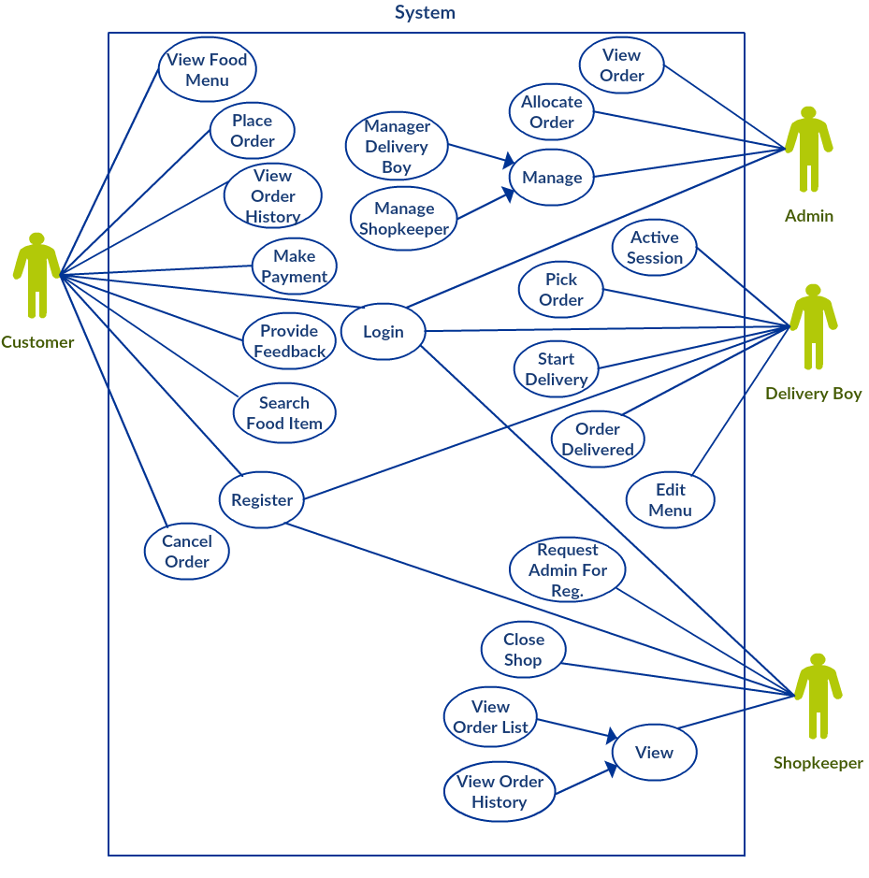

**Data Flow Diagram**

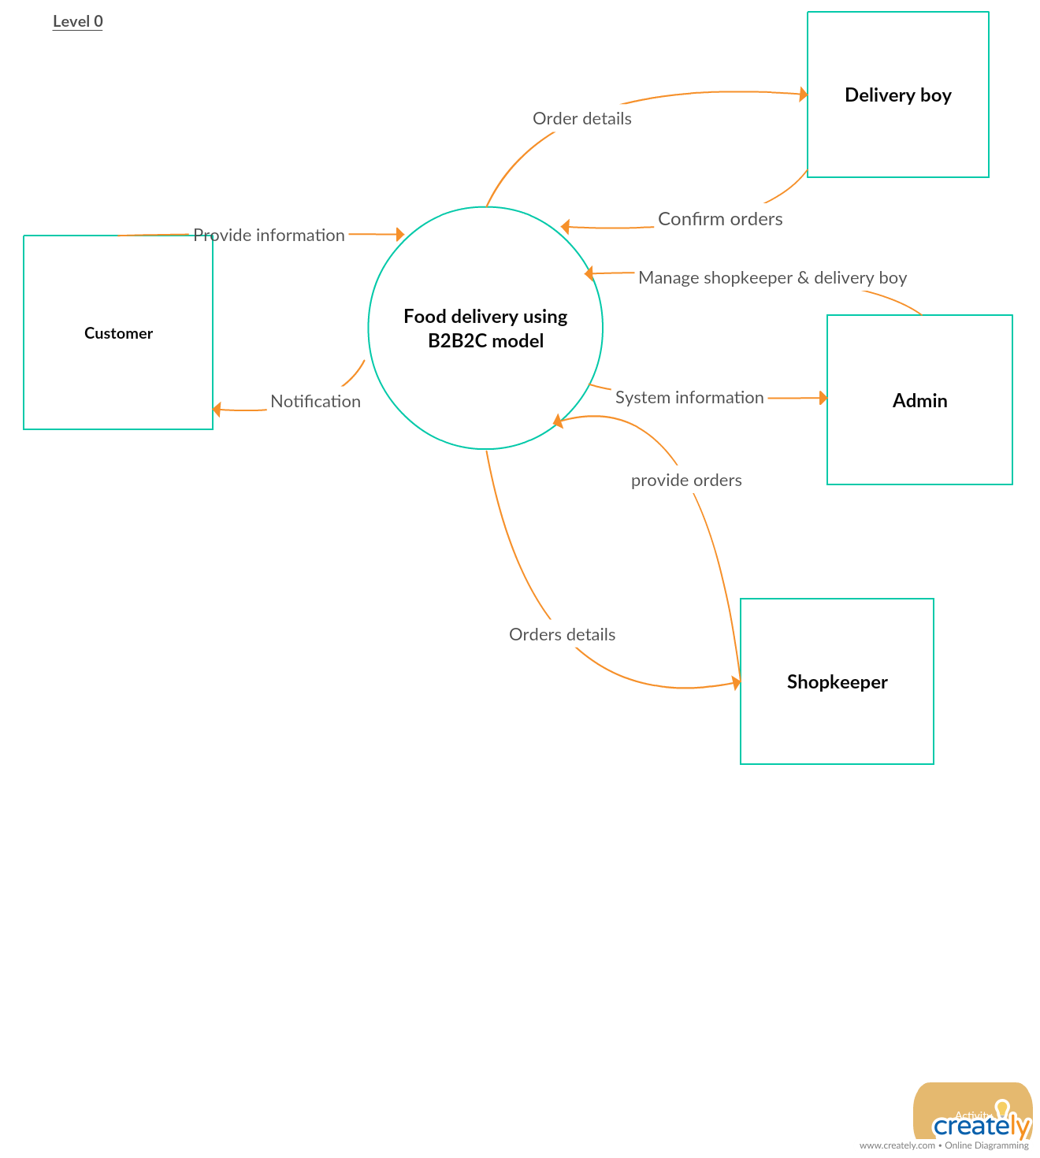

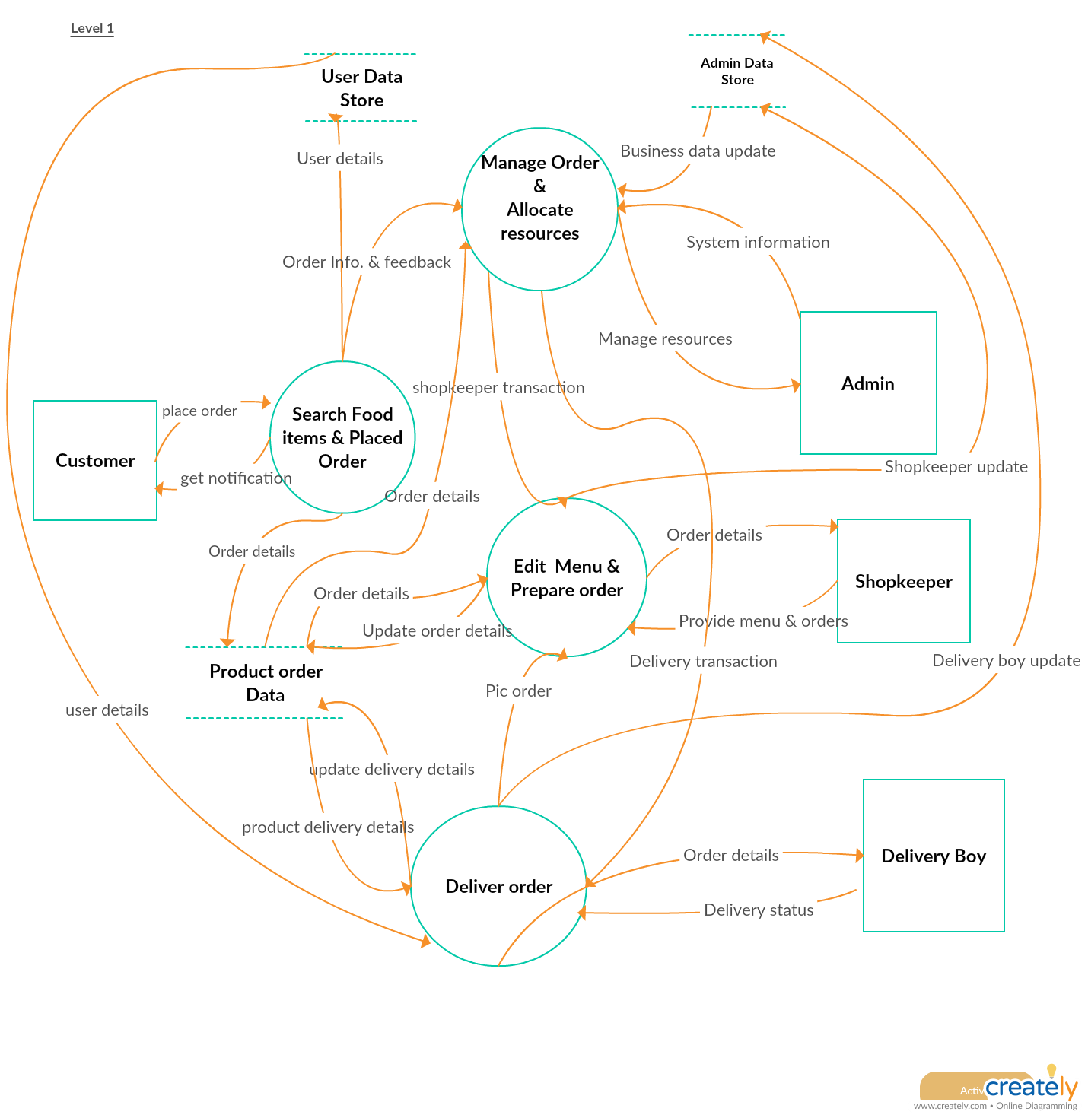

**Chapter : 4**

**Design**

**4.1. Architecture Diagram**

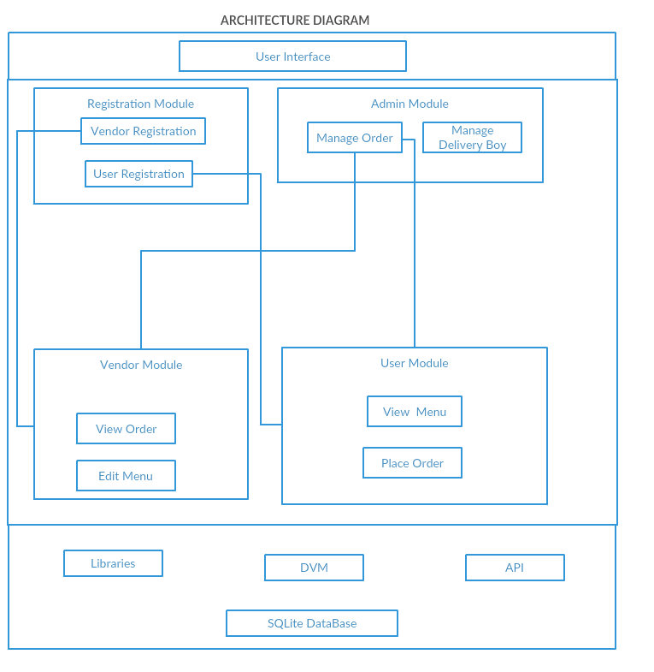

**4.2. Class Diagram**

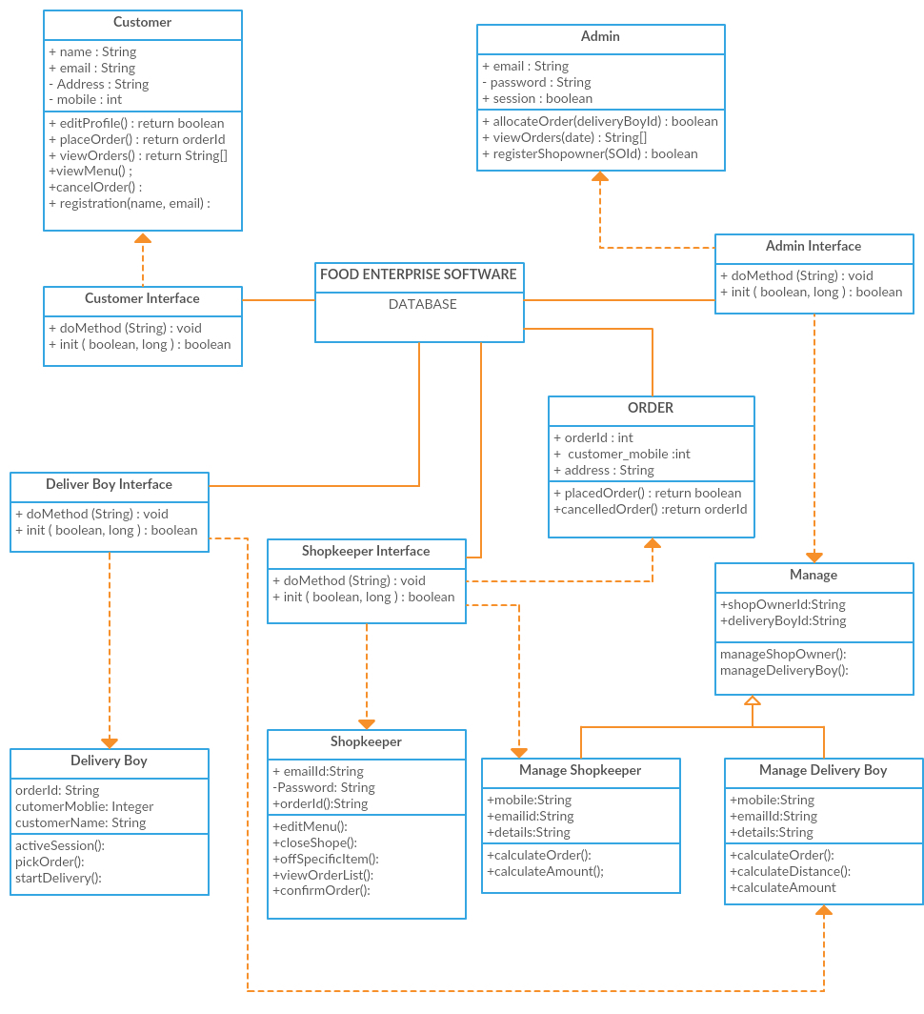

**4.3. Activity Diagram**

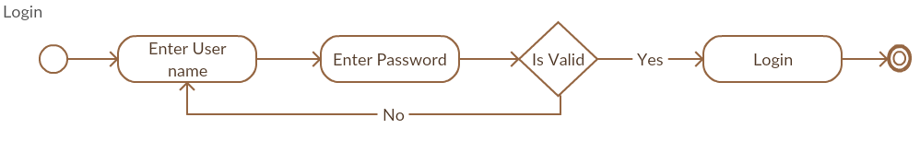

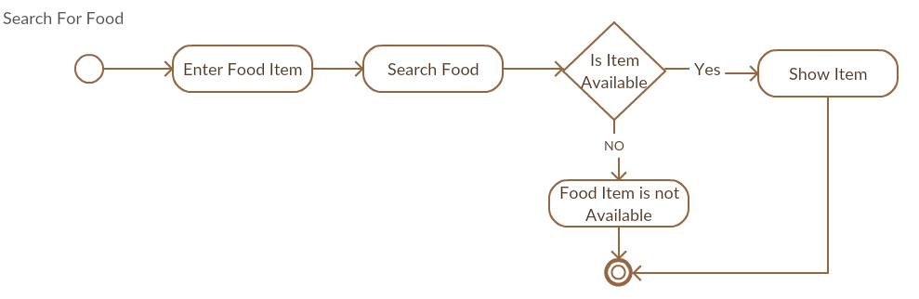

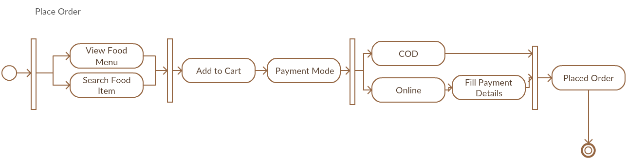

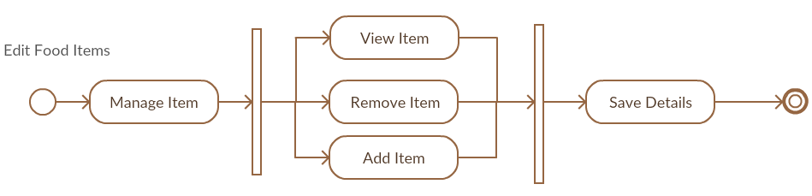

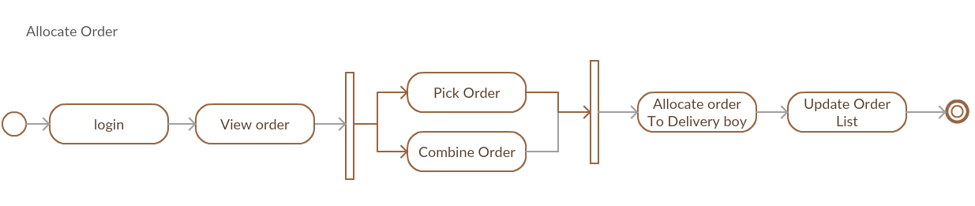

**4.4. Deployment Diagram**

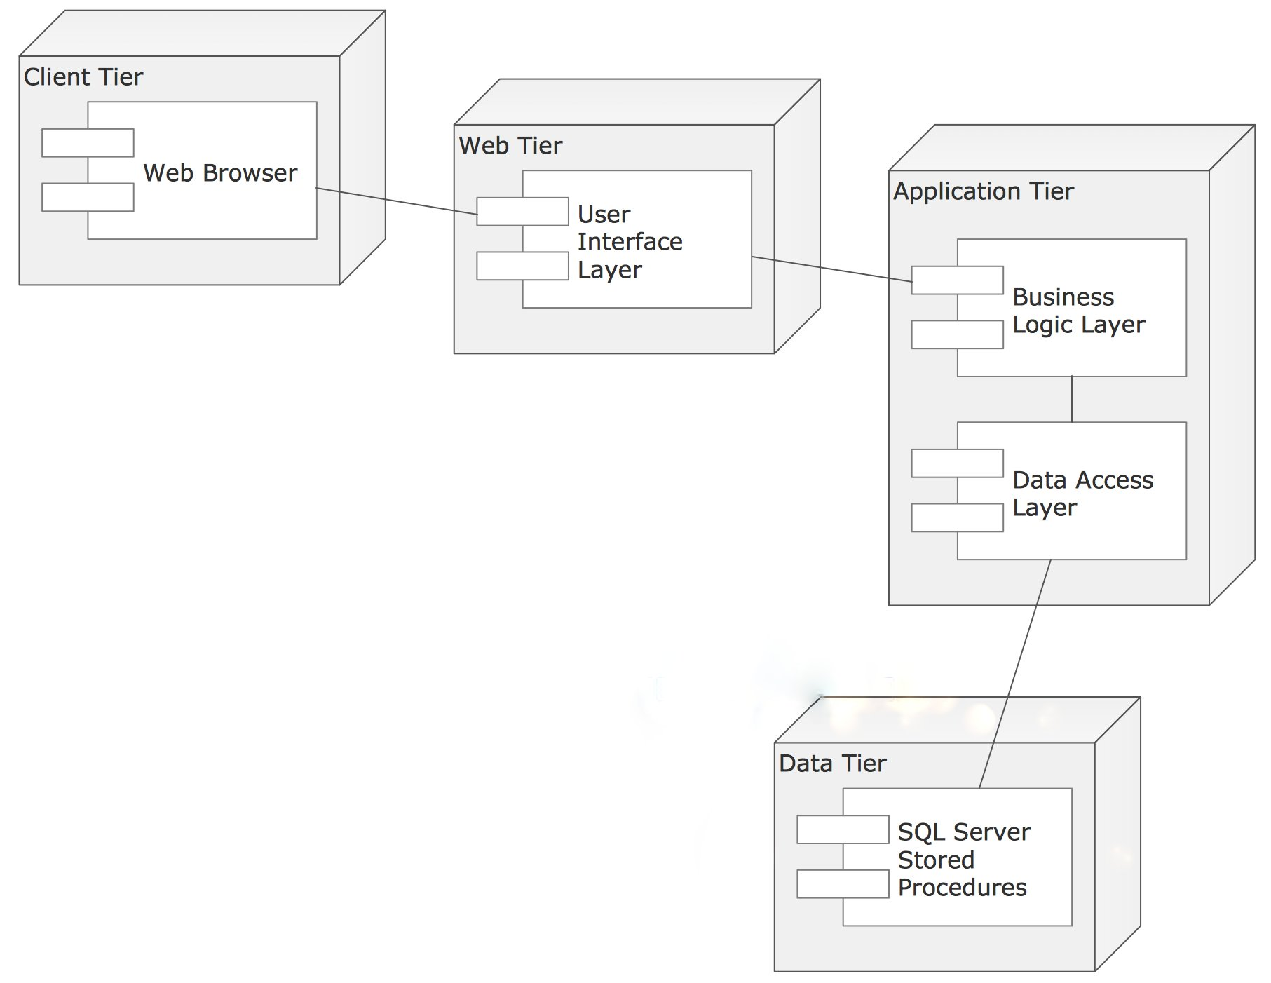

**Chapter : 5**

**Conclusion**

## **5.1 WORK CARRIED OUT IN PHASE-I:**

* Requirement of system is gathered.
* Detailed analysis of requirement has been done.
* Feasibility of system has been checked.
* Detailed designing of system has been done.

## **5.2 WORK CARRIED OUT IN PHASE-II:**

* Implementation of system will be performed.
* Testing will be done in phase II.
* Delivery of system to user will be done.